**Visualizations for Employee Sentiment Analysis**

1. **EDA - Sentiment Score Distribution:**

Histogram or density plot of the monthly employee sentiment scores (calculated as +1 * Positive + 0 * Neutral + -1 * Negative) to show the overall distribution.

1. **EDA - Monthly Sentiment Trend:**

1. **Overall Sentiment Distribution:**

1. **Monthly Sentiment Trend:**

1. **Linear Regression- Model Analysis:**

Scatter plot of Actual vs. Predicted sentiment scores from the Linear Regression model (on the test set), including the regression line to visually demonstrate its poor fit.

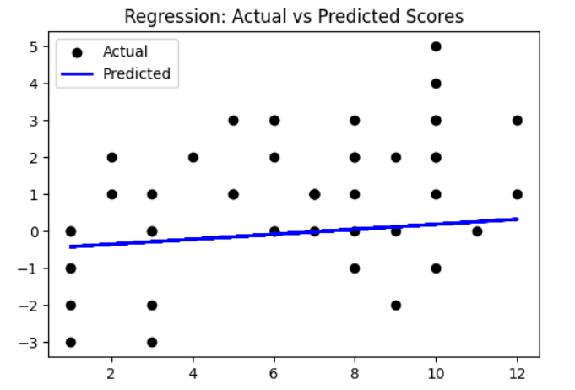

1. **Predictive Model - Random Forest Performance - Actual vs. Predicted:**

Scatter plot of Actual vs. Predicted sentiment scores from the Random Forest Regressor model (on the test set).

1. **Predictive Model - Random Forest Feature Importance:**

Bar chart displaying the feature importances from the Random Forest model (features like message count, Positive_count, Negative_count, Neutral_count, month_num).

1. **Flight Risk Analysis - Sentiment Over Time for Key Individuals:**

The existing line graph: "Sentiment Score Over Time - Top 3 Flight-Risk Employees" (showing John Arnold, Rhonda Denton, Kayne Coulter).

